**Assignment 3**

Create a Dockerfile:

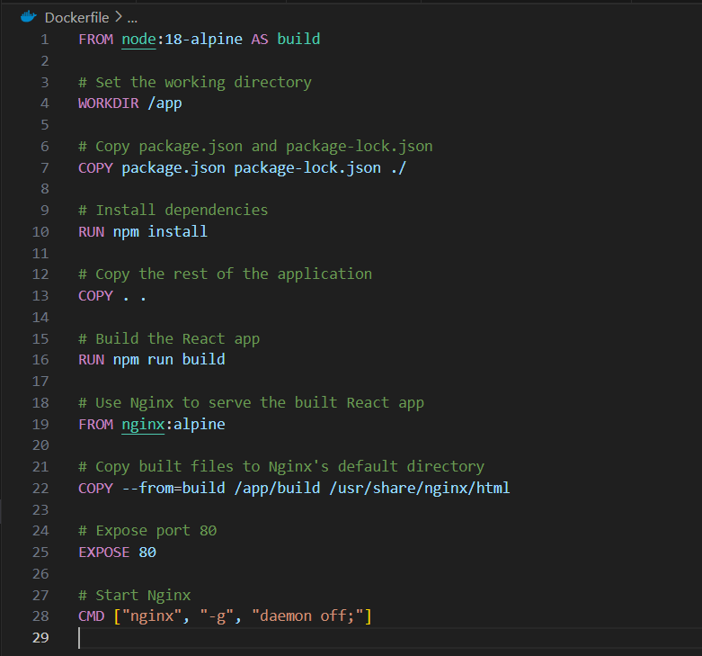

Create a docker-compose.yaml file:

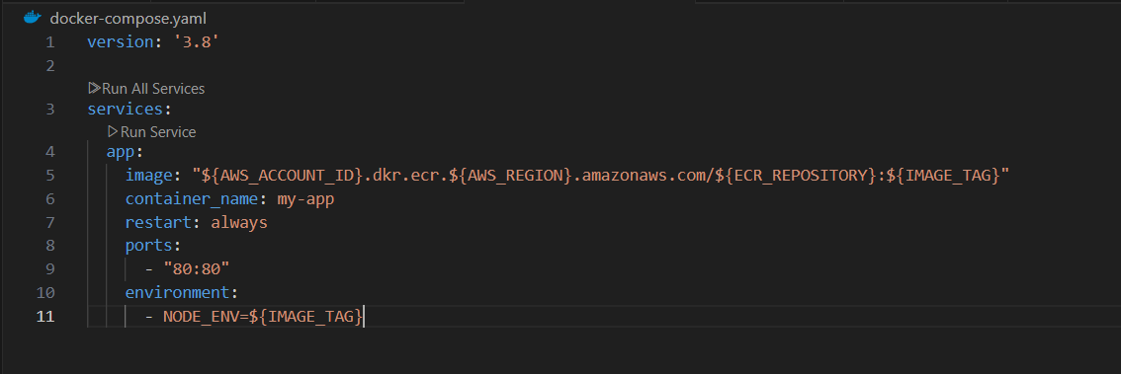

Create an AWS ECR Repository:

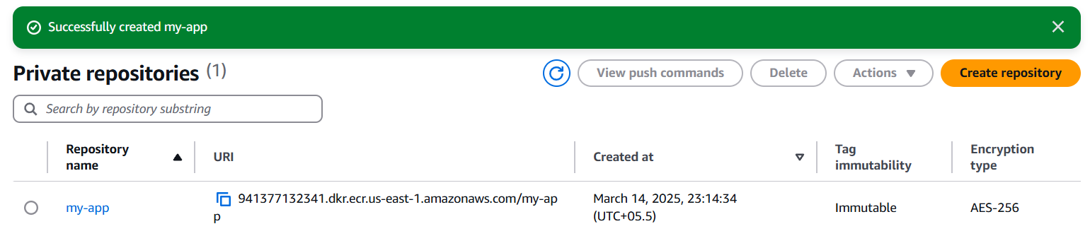

Set Up an AWS EC2 Instance:

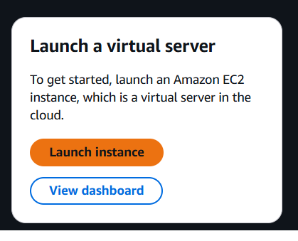

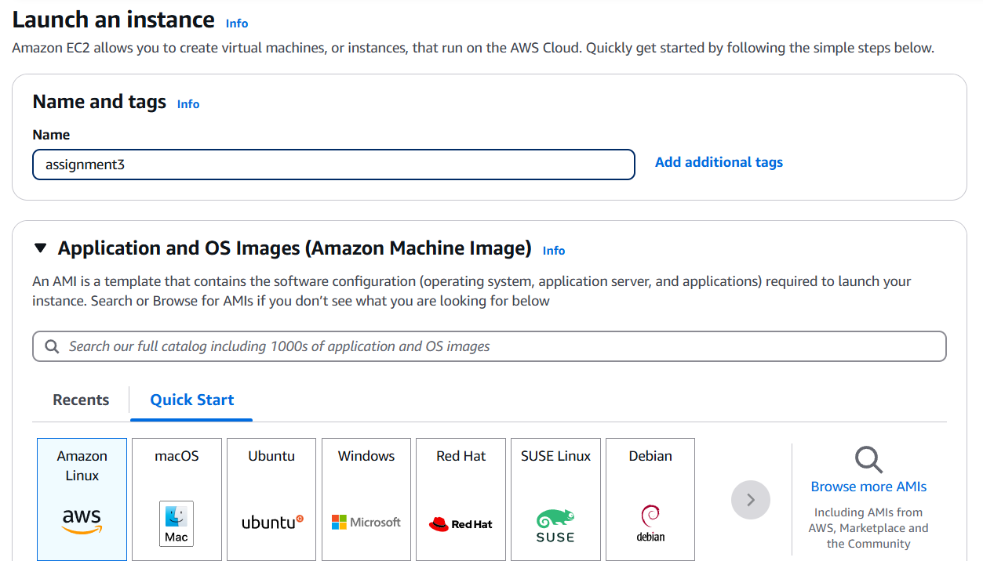

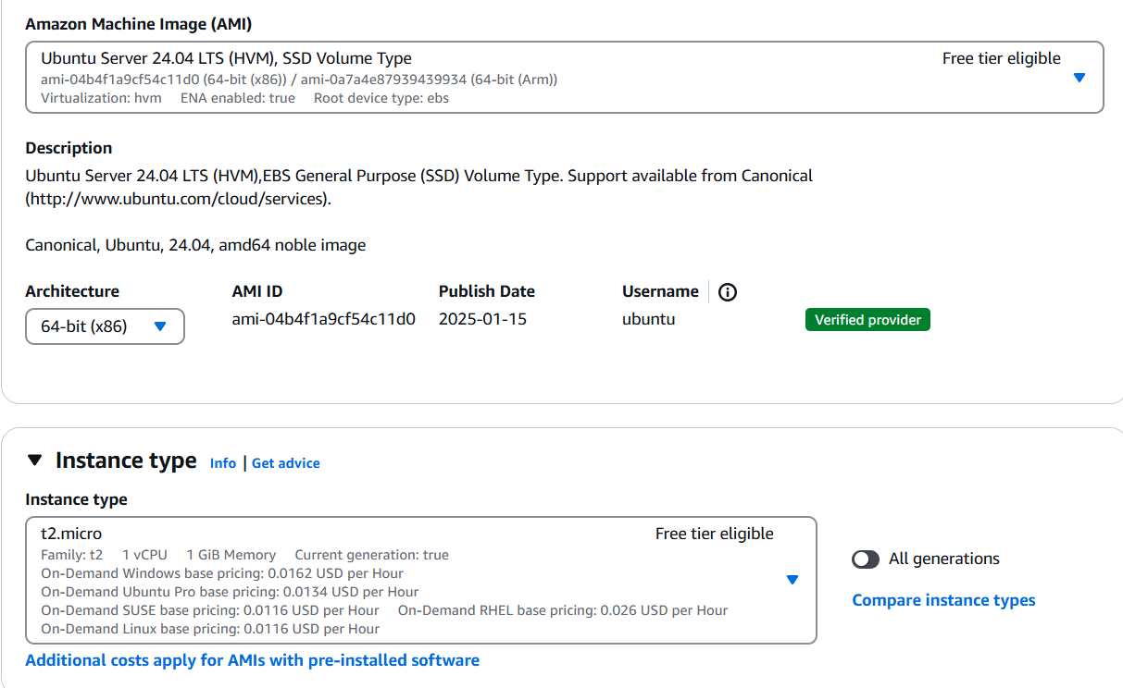

Create a key pair:

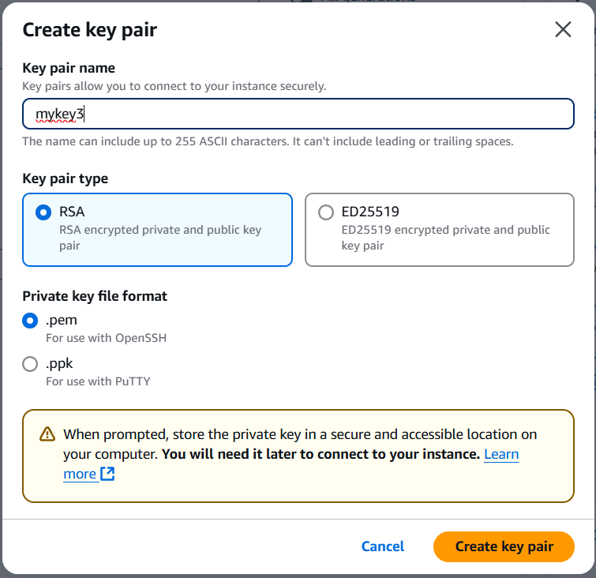

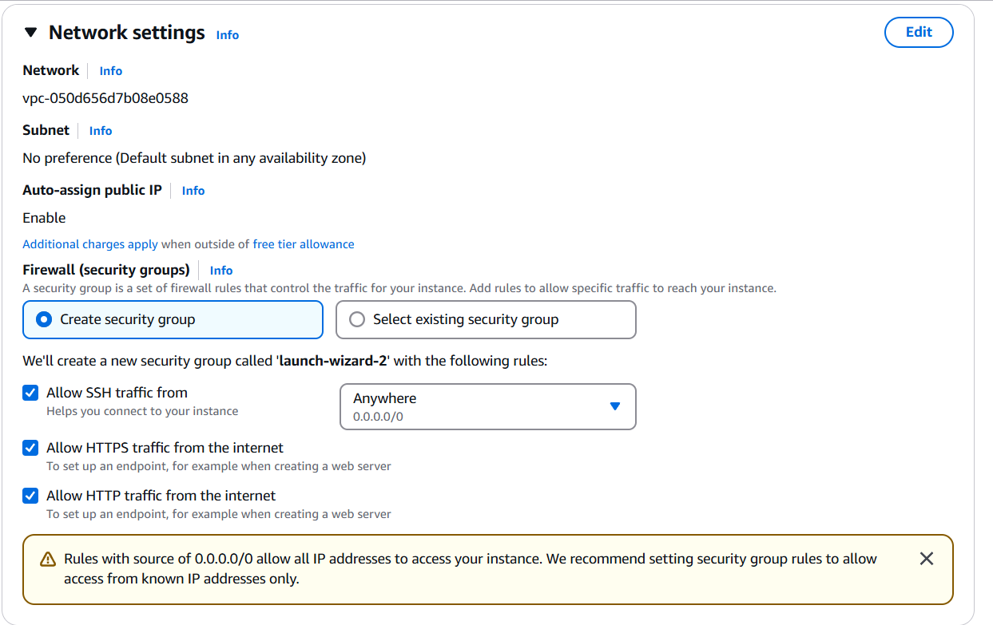

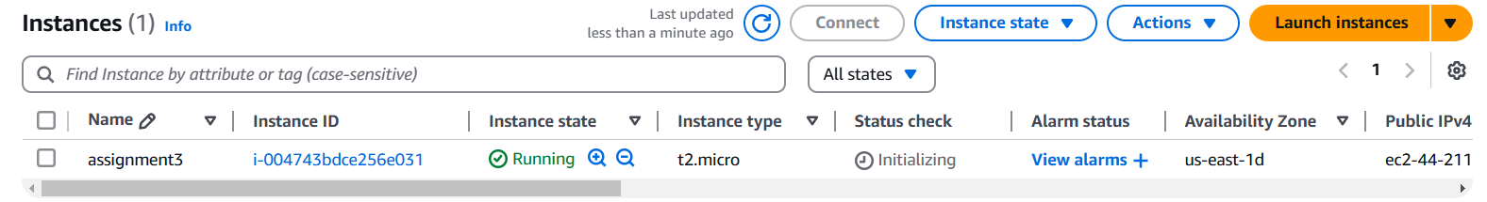

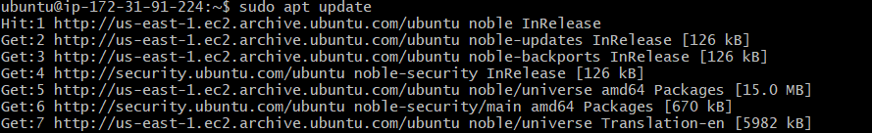

Install docker in the aws instance:

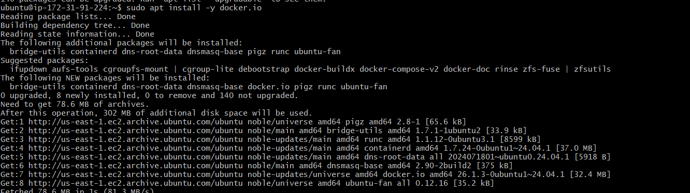





Configure IAM Permissions:

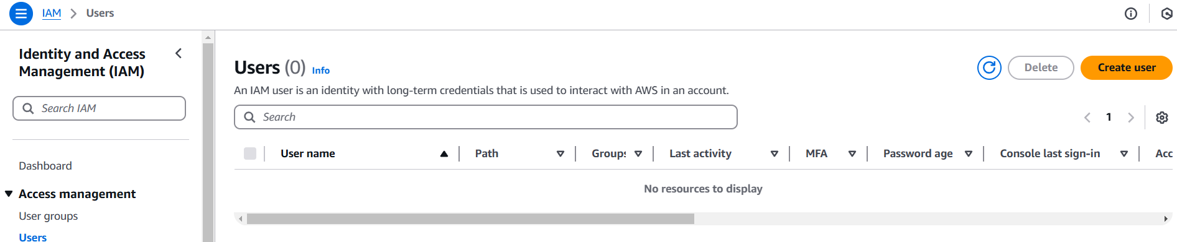

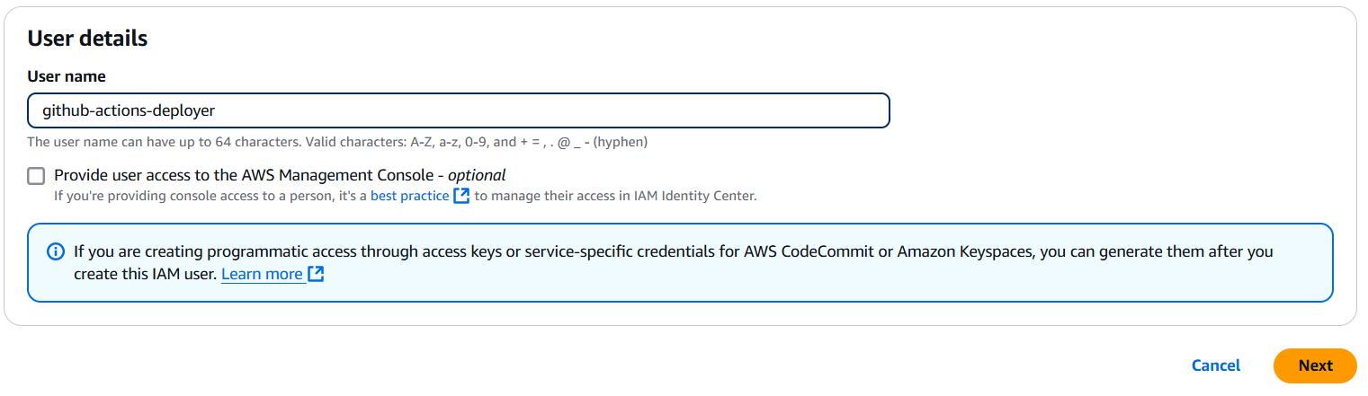

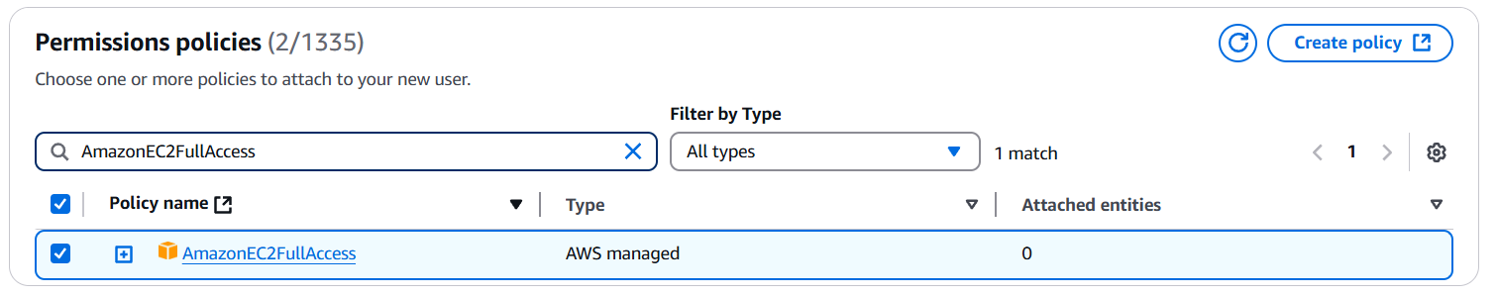

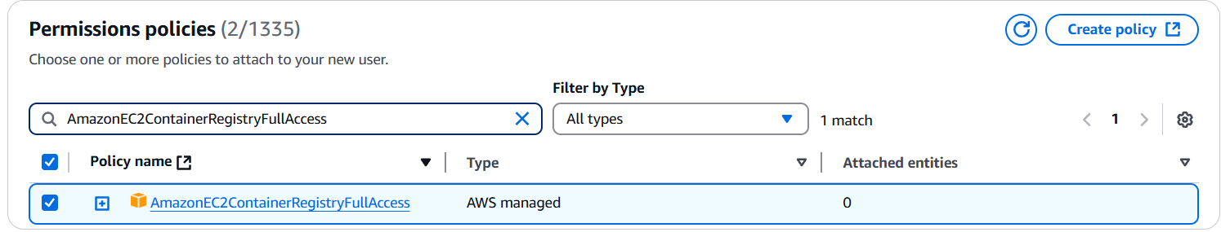

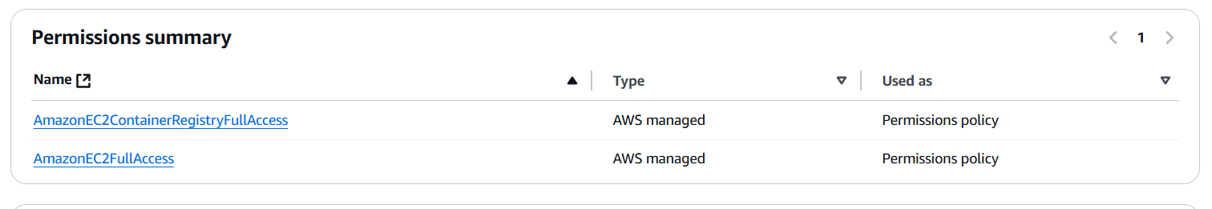

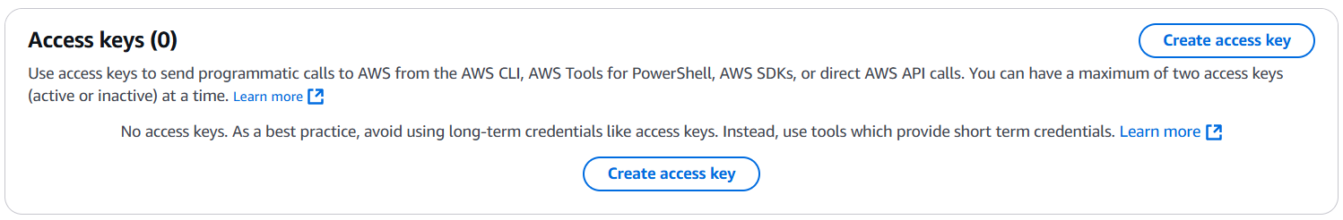

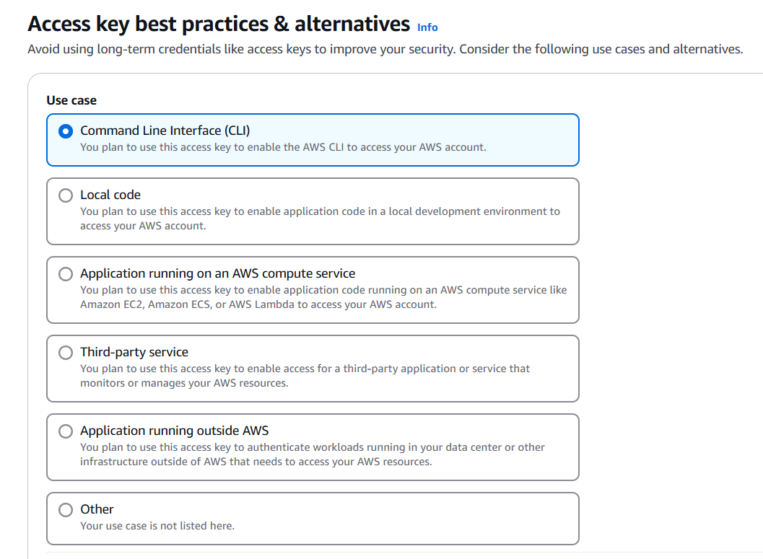

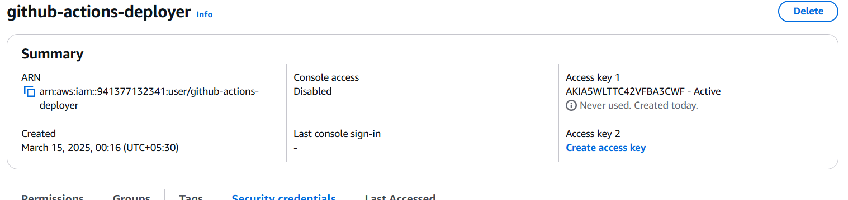

Store AWS Credentials in GitHub Secrets:

Add the following secrets:

* AWS_ACCESS_KEY_ID
* AWS_SECRET_ACCESS_KEY
* AWS_REGION (e.g., us-east-1)
* ECR_REPOSITORY (your ECR repo URI)
* EC2_HOST (your EC2 public IP)
* EC2_USER (usually ubuntu)
* EC2_SSH_KEY (your private SSH key, stored as a multi-line value)
* AWS_ACCOUNT_ID

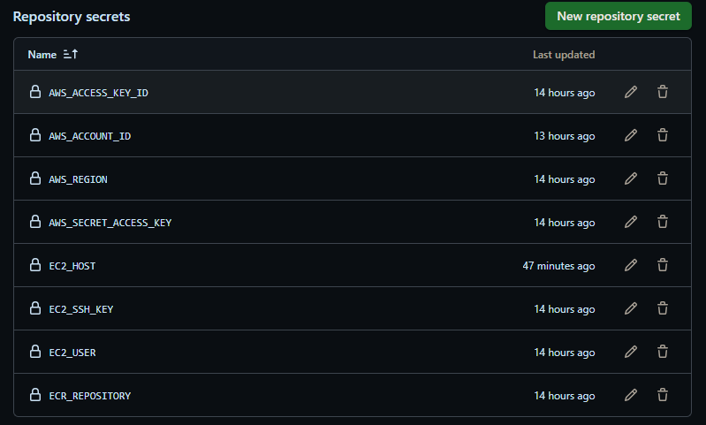

Prepare Your GitHub Repository:

* dev.yaml
* staging.yaml
* prod.yaml

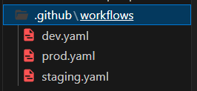

Prod.yaml file:

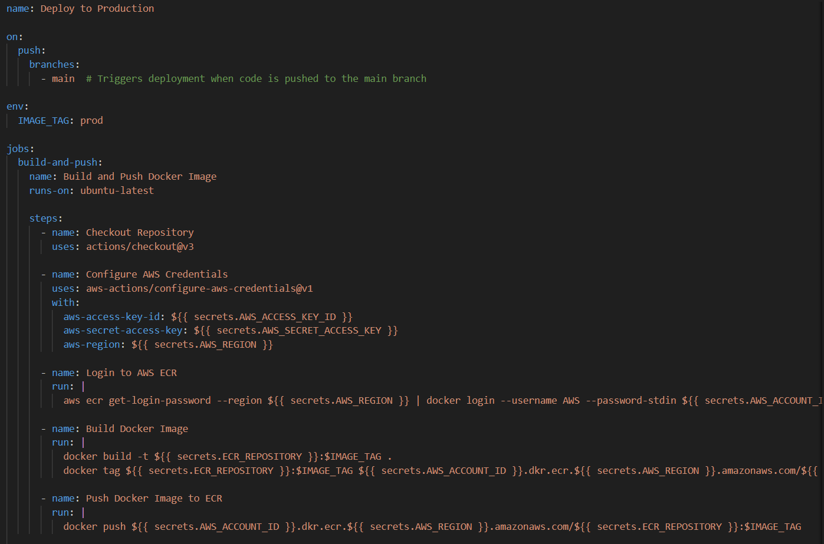

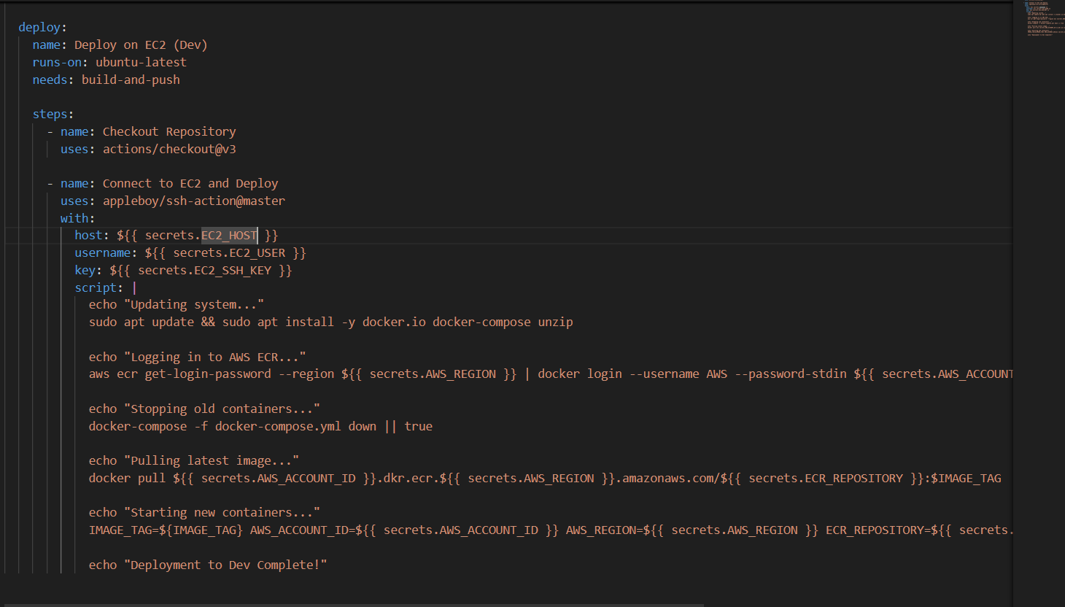

dev.yaml file:

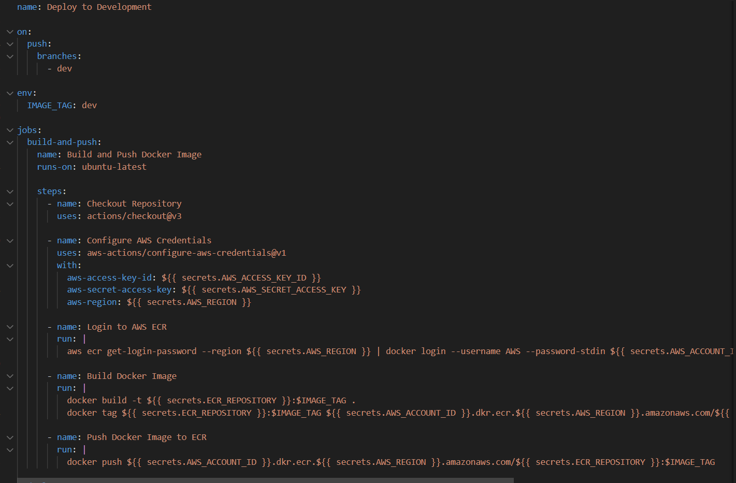

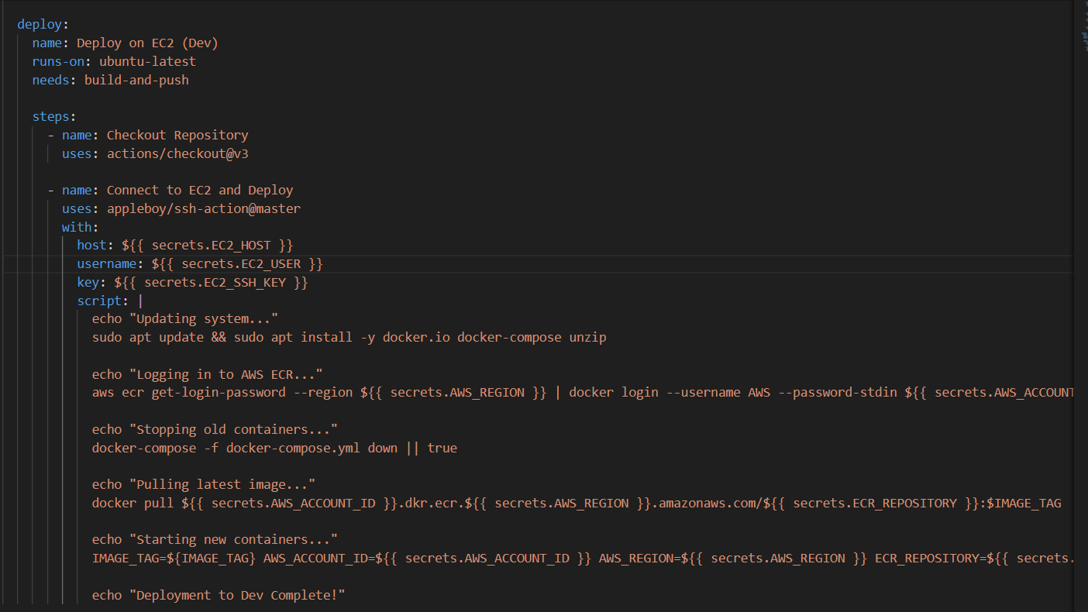

staging.yaml file:

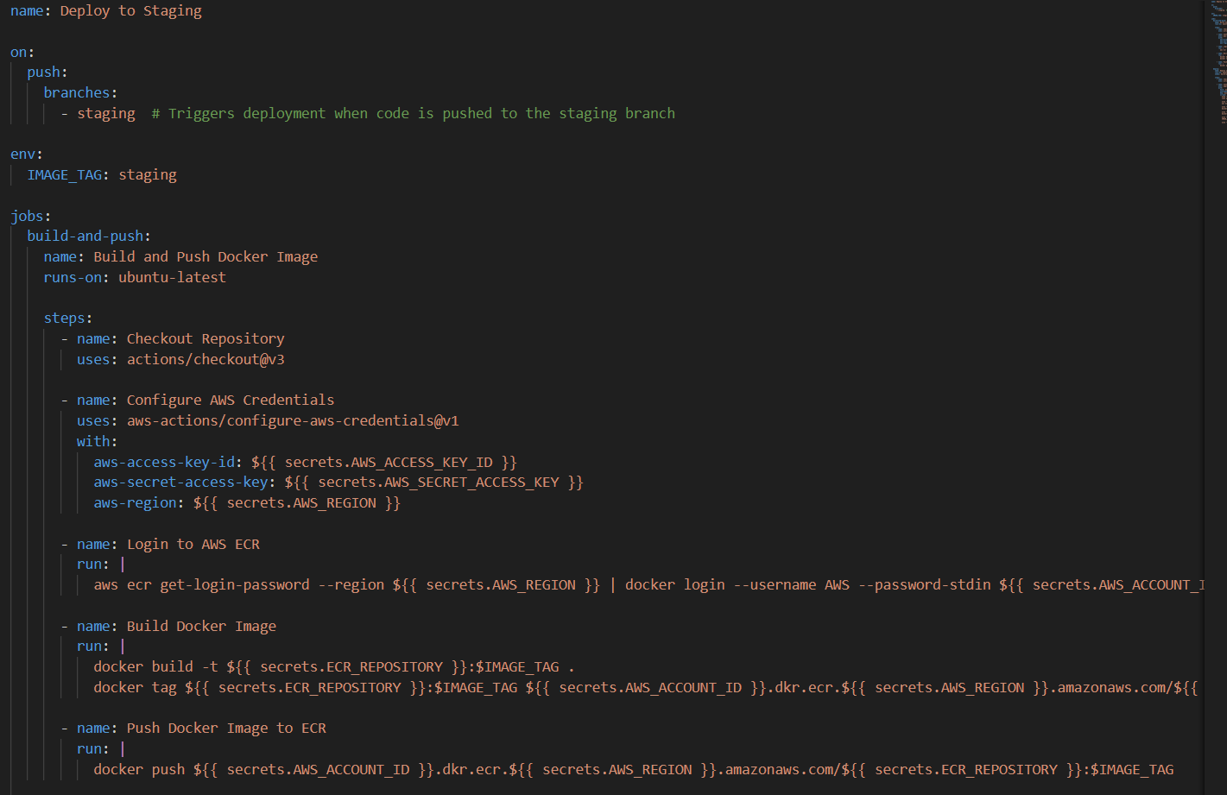

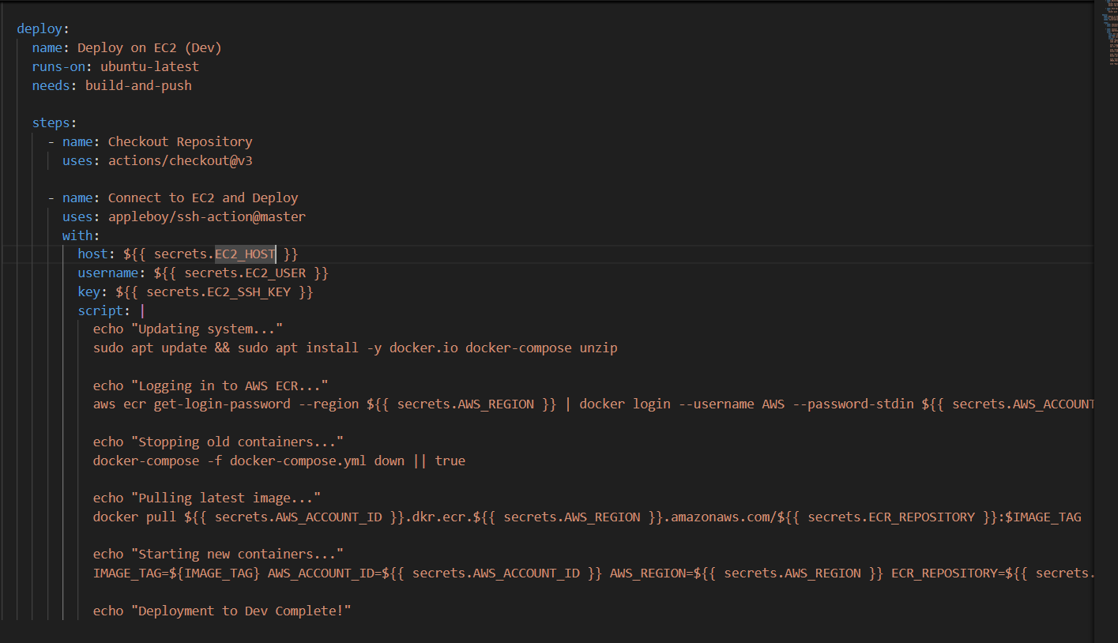

* Push to dev branch → dev.yaml runs → Deploys dev version
* Push to staging branch → staging.yaml runs → Deploys staging version
* Push to main branch → prod.yaml runs → Deploys prod version

Login to ecr:



Push code to the main branch

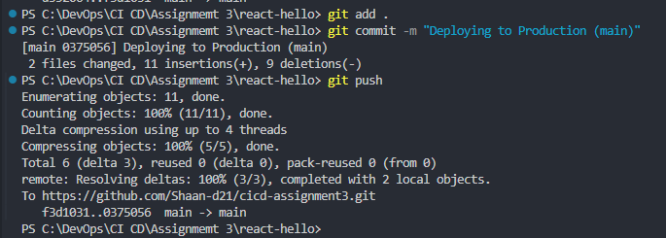

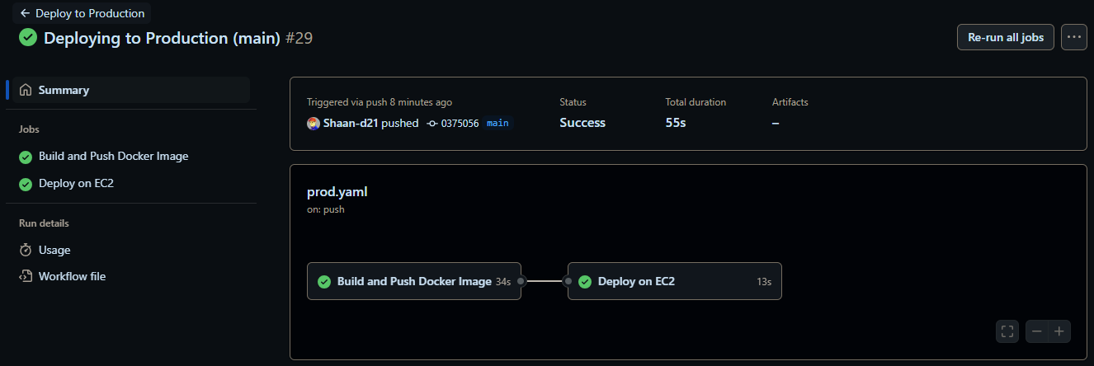

React app is accessible at: http://44.201.140.54/

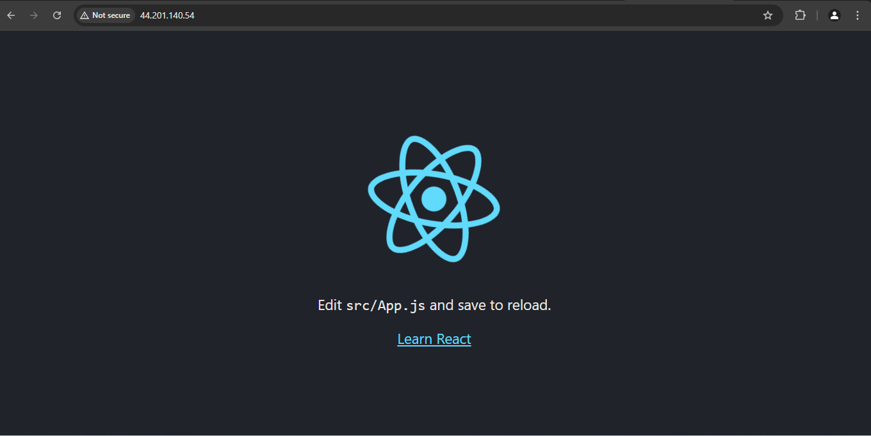

Push code to the dev branch:

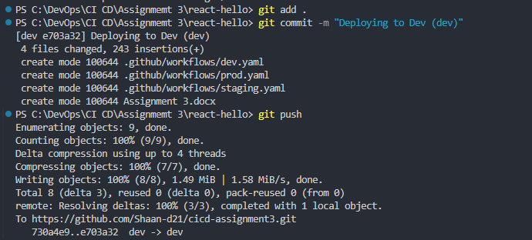

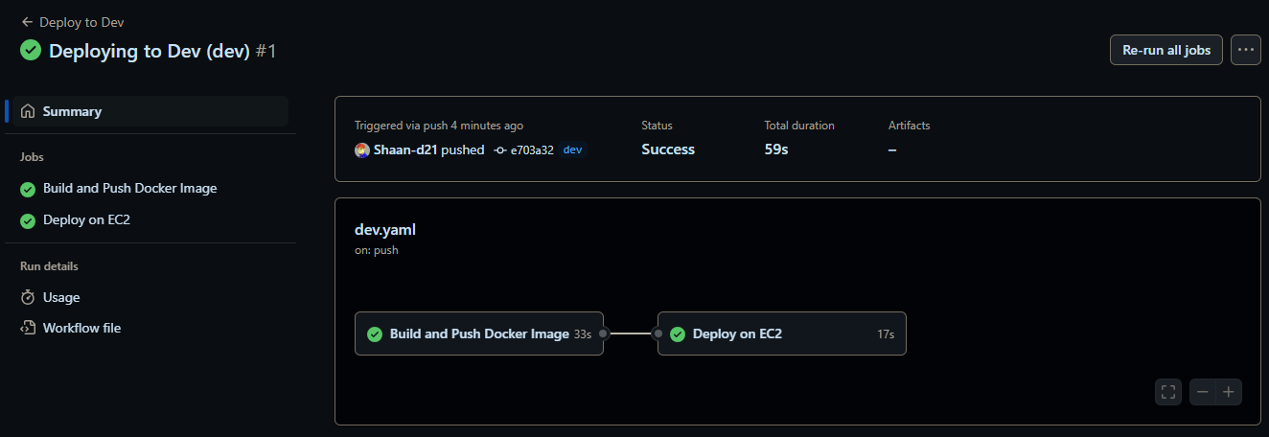

React app is accessible at: http://44.201.140.54/



Push code to the staging branch:

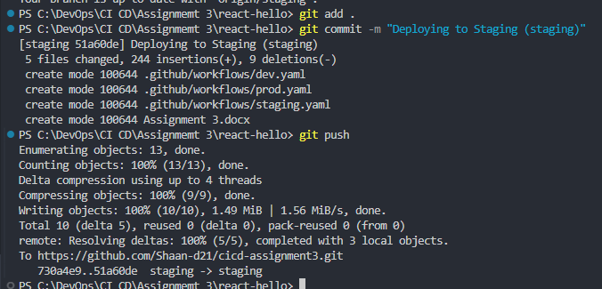

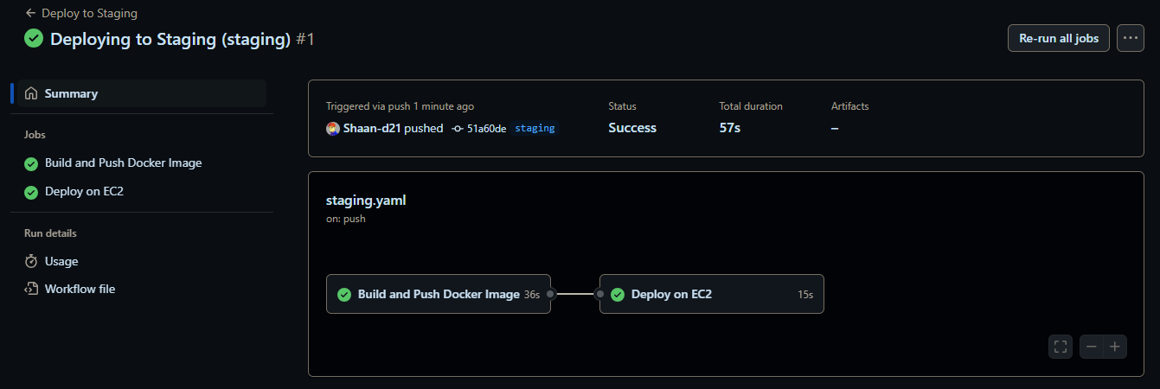

React app is accessible at: http://44.201.140.54/

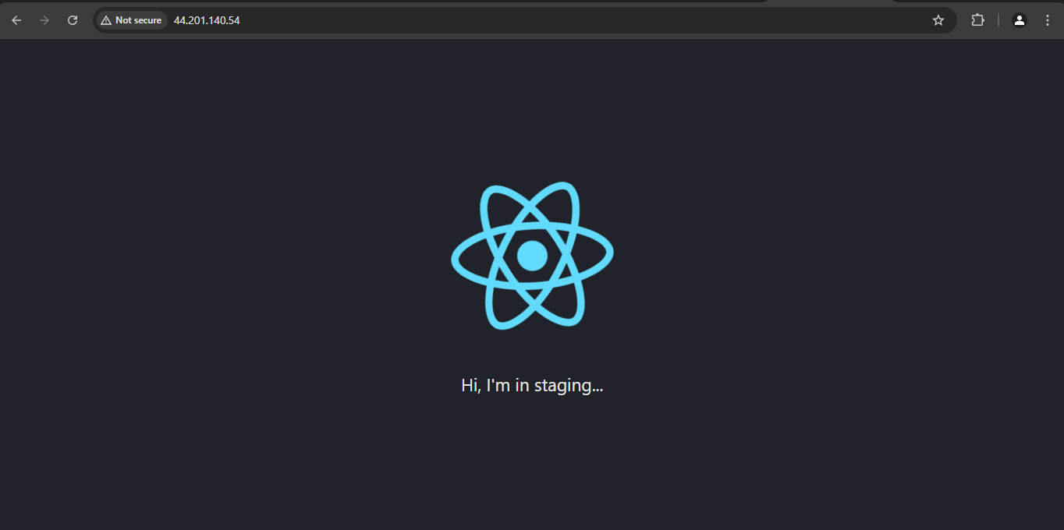

Images created with respective tags:

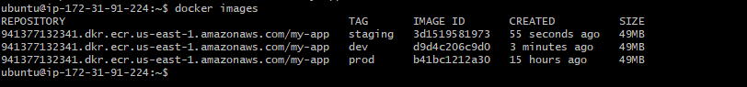

Container is running:

